Owners Update Registration
including Confirmation of
Identity and Bank Payment Authority

TRUSTS & INCORPORATIONS – please tick all that applies to you.
Haumingi 1A2 Trust Kokako Trust Mangorewa Kaharoa A Trust
Ngāti Manawa Incorporation Paengaroa South 5 Trust Parekarangi A4 Trust
Te Whaiti Nui A Toi Trust Waione 3B8 Incorporation
INDIVIDUAL CONTACT DETAILS
Full name: _______________________________________________________________________________________
Other Names known by (if any): ____________________________________________________________________
Date of Birth: ________________________________________________ Gender: Male / Female / Other
Postal Address: ___________________________________________________________________________________
__________________________________________________________________________________________________
Phone No: (Mobile): ___________________________________(Home/Work): ______________________________
Email Address: ___________________________________________________________________________________
IRD Number: ____________________________________________
PERSONAL IDENTIFICATION REQUIRED
Attach copy of either: Current Drivers Licence or Current Passport
MĀORI LAND COURT VESTING ORDERS
Reference Number: _________________________________
Ownership Verification Required: ___________________
Māori Land Online Number: ________________________(www.maorilandonline.govt.nz)
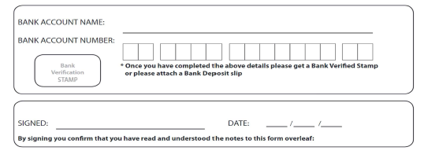
Or Copy MLC Vesting Order attached: _________________

WHAKAPAPA (Optional):
Mother’s Full Name: ______________________________________________________________________________
Father’s Full Name: _______________________________________________________________________________
Spouse’s Full Name: ______________________________________________________________________________
Brothers and Sisters Full names (including deceased and whangai):
Names | Email or Phone (if known)

Your Children’s full names (including whangai):
Names | Email or Phone (if known)

CONSENT AND ACKNOWLEDGEMENT:
1. By signing this form, the owner authorises payment of grants and/or dividends to their nominated bank account.
2. The information collected by this form will enable you to receive communications from the Trust by email or post and obtain the correct benefits and to assist the Trust to locate other owners who may be entitled to registering and benefits.
3. This information is intended for the Trusts and Incorporations managed by Awhi Rōpū Consultants, P.O. Box 987 Rotorua, as well as their employees and contractors, for the purpose of administration.
4. Failure to provide the information requested information may result in your registration application being delayed or not declined.
5. You have the right of access to, and correction of, information held about you subject to the provisions of the Privacy Act 1993.
----------------------------------------------------------------------------------------------
FOR OFFICE USE ONLY:
Date Application Received: ____________________________
Document validation: IRD Number Supplied Yes/No
Bank Account Verified Yes/No
Identification Supplied Yes/No
Application Approved On: ______________________
Applicant Notified On: _________________________

